Quiz 04 Solution

Name: Student ID:

Could you give an example, including both the knowledge base and the query procedure to show the difference between forward chaining and backward chaining of knowledge-based agent?
Knowledge-base
A
B
C
A ∧ B ⇒ D
B ∧ C ⇒ E
A ∧ C ⇒ F
A ∧ F ⇒ G
D ∧ F ⇒ K
G ∧ K ⇒ Q1
E ⇒ H
H ∧ C ⇒ Q2

Query Q2

Forward

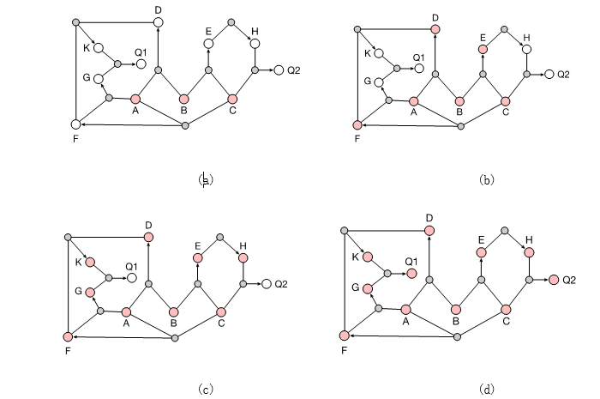

Backward

